

**e-Yantra Robotics Competition - 2019-20**

**Implementation Analysis: Construct-O-Bot**

**Team 0511**

|  |  |
| --- | --- |
| **Team leader name** | M Shyam |
| **College** | SdNational Institute of Technology, Trichy |
| **Email** | [m.shyam.tnj@gmail.com](mailto:m.shyam.tnj@gmail.com) |
| **Date** | 06-01-2019 |

**a. State the scope of the theme assigned to you.**

**(5)**

< Team should briefly explain in their own words the theme assigned. What in your opinion is the purpose of such an application?

Answer format: Text, Word - limit: 100 words>

**b. Upload the Final Arena Images as per configuration given in the rulebook.**

**(5)**

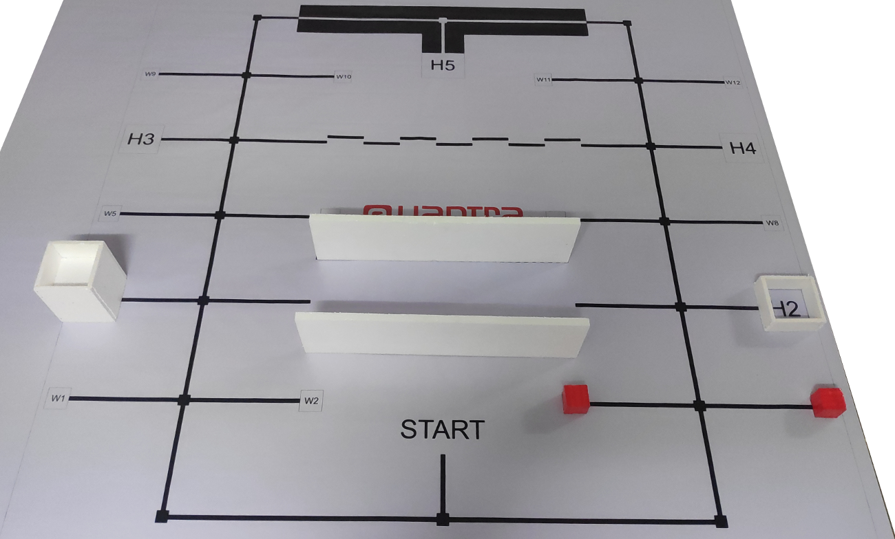

**c. Team have to design a robot to solve the problem as mentioned in the rulebook. Attach the final robot design in the answer. Why have you come up with such a design? (20)**

    <Attach picture from different angle of your designed robot. You can mark the component placement on the top of picture. Also mention the strategy of this design (for explanation you can use some animation or hand drawn photos) along with advantages and disadvantages in comparison to other designs.

Note: Teams with “good” design based on the functionality and aesthetics will be given more marks.

You can use bullet points like:

1. Sensor Placement
2. Arm Mechanism
3. etc.

Word-limit: 150 words. >

**d. Using the designed robot, make it move by 10 cm forward, 10 cm right, 10 cm left and 10 cm backward. (15)**

<Put the unlisted YouTube video link of the above process here>

**e. Identify the major components provided to you and explain the role/purpose of each component that is required for designing the robot for the theme. (5)**

< Team should classify the components into various categories: mechanical systems, electronic systems etc. and mention how these units will be used in the theme. You may draw diagrams/figures to illustrate your answer.

Answer format: Bulleted form

1. Component 1

2. Component 2

3. ….etc. >

.

**f. Explain the components that you will be using to design the robotic arms and its working for the theme. How the arm will be mounted on the robot (left, right, back, front) , also justify your mounting strategy. (10)**

< Team should classify the components into various categories: mechanical systems, electronic systems etc. and mention how these units will be used in the theme. You may draw diagrams/figures to illustrate your answer.

Answer format: Bulleted form

1. Component 1

2. Component 2

3. ….etc. >

**Mechanical components**

**Electrical Components**

1. Servo : used for the movemen

**g**. **What are the challenges would you expect to face while designing the robotic arms to pick and place the Construction Materials and how will you overcome them? (5)**

< Answer format:

Challenge 1:

Solution 1:

Challenge 2:

Solution 2:

….…etc. You can also draw some diagrams/figures to illustrate your answer in a better way.>

**h. In this theme, we use the following formula as mentioned in Judging and Scoring section of Rulebook:**

**Total Score = (600-T) + (CP*30) +(CD1*80) + (CD2*100) + (WHB*100) + (B*100) – (P*50)**

**What will be your strategy to earn maximum points and Bonus points in a run ( given the following Configuration Table)? (10)**

|  |  |  |  |
| --- | --- | --- | --- |
| **House** | | **Construction Materials Required** | |
| H1 | low-rise | Brick | Sand |
| H2 | high-rise | Gravel |  |
| H3 | high-rise | Cement | Brick |
| H4 | low-rise | Electrical fittings | Sand |
| H5 | high-rise | Gravel | Paint |

We are using A* algorithm to find the shortest path. And the algorithm requires a cost-function between nodes to find the shortest path. So, we are planning to incorporate the points assigned to each warehouse/house into it so that the bot would prefer completing a certain requirement, even if it takes longer than completing some other requirement. By carefully calibrating the constants involved in distance component and points components involved in the cost function, the bot will be able to come up with the most optimum order of solving the requirements.

**i. Explain your strategy in following (10)**

1. **Wall,**
2. **Zig- Zag and**
3. **White line**

**Wall:**

One of the sharp distance sensors (which will be fixed on one of the sides of the bot) is employed for wall-following. An optimum distance is fixed through repeated experimentation and PID is again used to follow the wall using the readings from the distance sensors instead of the line sensors.

**Zig-Zag lines:**

Currently, we have an idea, where we will simply alter the target value for the PID algorithm to appropriate values whenever patterns 100 or 001 are detected, thus, following the mid-point of the zig-zag lines.

**White Line:**

We employ the PID algorithm to follow both the colored lines. When the bot encounters a configuration of 101 (1 representing a black and 0 representing white), the bot switches to an “inverted” state where the sensor readings are inverted. Therefore, in the “inverted” state 1 denotes white and 0 denotes black. Once the bot detects the pattern 101 again, the inverted mode is again toggled, thus continuing the normal operation.

**j. Draw the complete flow chart of the algorithm used to solve the problem. (15)**

**<**Use proper flowchart methodology. You can use already available software/application for creating flowcharts.

Important functions should be clearly explained.>

**Best of Luck!**